**NAME:SHREYASH PANAGE**

**ROLL NO: 58**

**BRANCH: AIDS**

# Practical No. 4

**Aim:** To Perform various data manipulation queries, aggregate functions, sorting concept, single row functions

**Problem Definition:** Solve the following queries on the tables created in practical No. 3

1. List out the employee id, last name in ascending order based on the employee id.

SELECT Employee_Id, Last_Name

FROM EMPLOYEE

ORDER BY Employee_Id ASC;

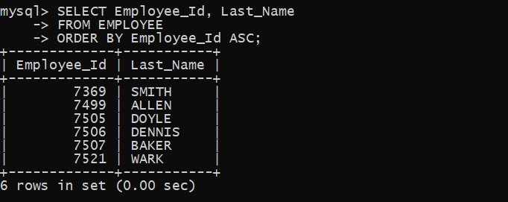

1. List out the employee id, name in descending order based on salary 2 column.

SELECT Employee_Id, CONCAT(First_Name, ' ', Last_Name) AS Name

FROM EMPLOYEE

ORDER BY Salary DESC;

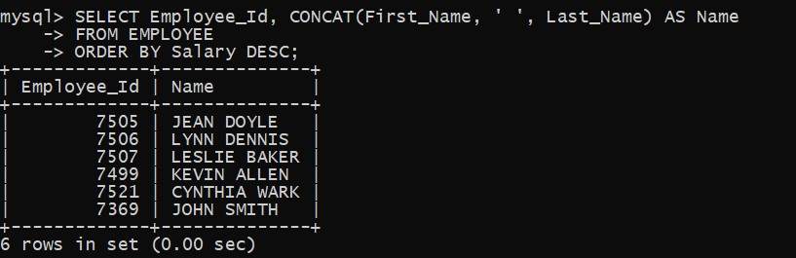

1. **List out the employee details according to their last_name in ascending order and salaries in descending order.**

SELECT Employee_Id, Last_Name, First_Name, Salary

FROM EMPLOYEE

ORDER BY Last_Name ASC, Salary DESC;

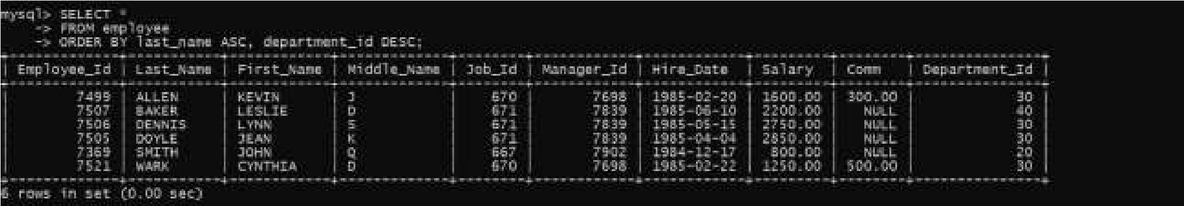 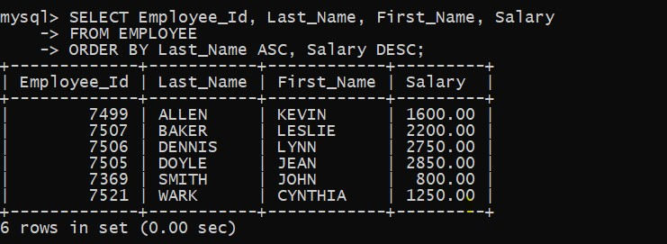

1. **List out the employee details according to their last_name in ascending order and then on department_id in descending order**

SELECT *

FROM employee

ORDER BY last_name ASC, department_id DESC;

1. **How many employees who are working in different departments wise in the organization**

SELECT department_id, COUNT(*) AS num_employees

FROM employee

GROUP BY department_id;

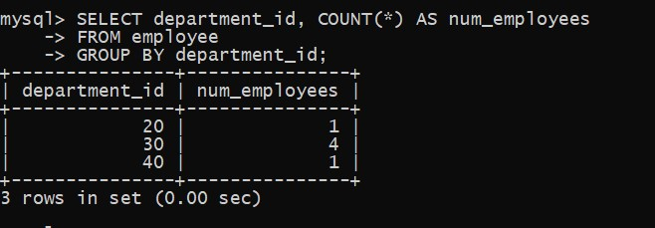

1. **List out the department wise maximum salary, minimum salary, average salary of the employees**

SELECT department_id,

MAX(salary) AS max_salary,

MIN(salary) AS min_salary,

AVG(salary) AS avg_salary

FROM employee

GROUP BY department_id;

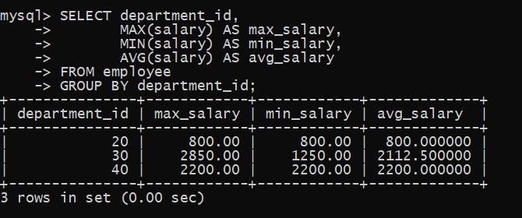

1. **List out the no. of employees for each month and year, in the ascending order based on the year, month.**

SELECT YEAR(hire_date) AS year, MONTH(hire_date) AS month, COUNT(*) AS num_employees

FROM employee

GROUP BY year, month

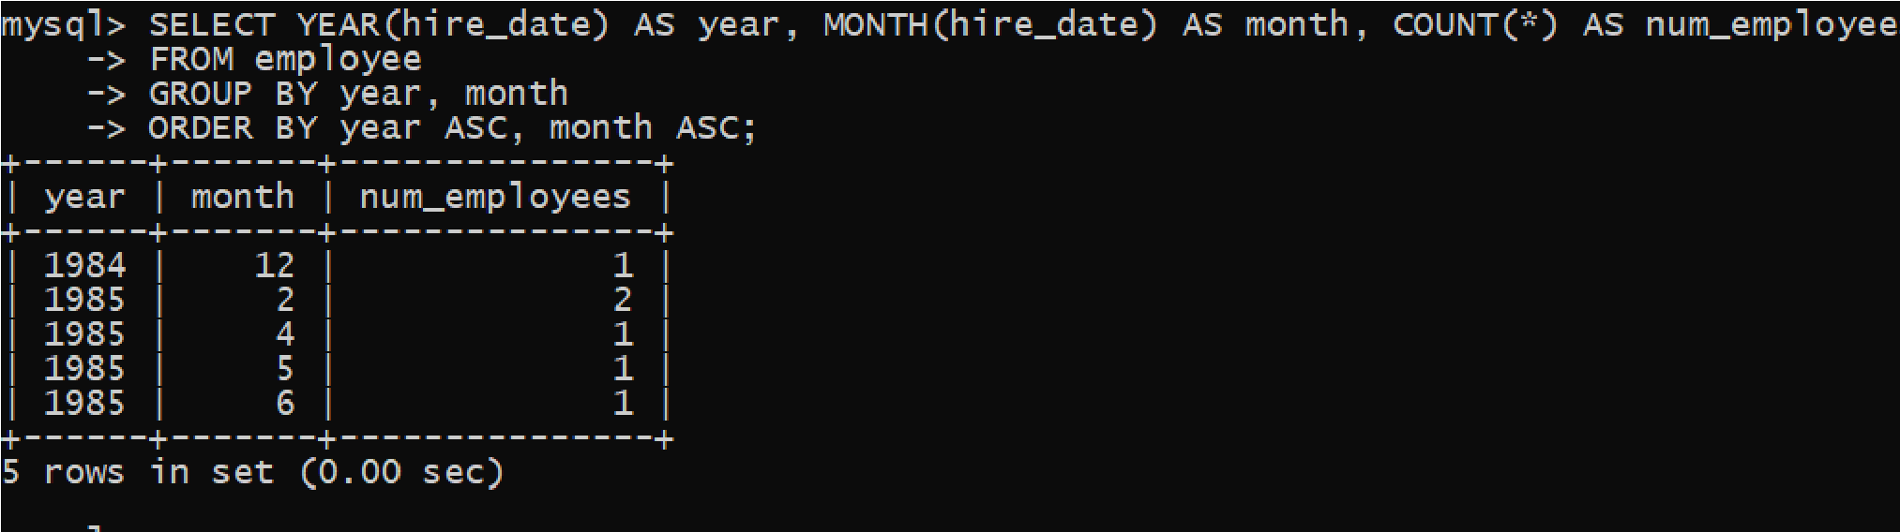ORDER BY year ASC, month ASC;

1. **List out the department id having at least four employees**.

SELECT department_id, COUNT(*) AS employee_count

FROM employee

GROUP BY department_id

HAVING COUNT(*) >= 4;

0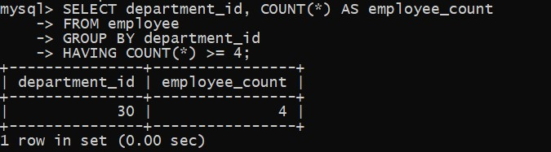

1. **How many employees in January month.**

SELECT COUNT(*) AS num_employee_joined_jan

FROM employee

WHERE MONTH(hire_date) = 1;

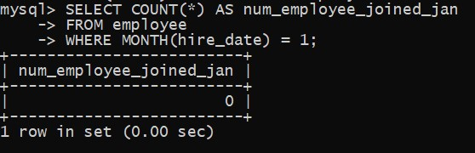

1. **Which is the department id, having greater than or equal to 3 employees joined in April 1985.**

SELECT department_id

FROM employee

WHERE hire_date >= '1985-04-01' AND hire_date < '1985-05-01'

GROUP BY department_id

HAVING COUNT(*) >= 3;

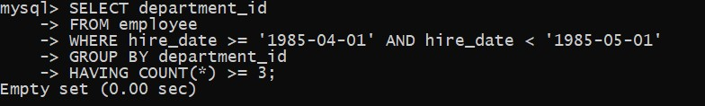

## CONCLUSION: IN THESE PRACTICAL PERFORM VARIOUS DATA MANIPULATION QUERIES, AGGREGATE FUNCTIONS, SORTING CONCEPT, SINGLE ROW FUNCTIONS